North American Wetlands Conservation Act
2012 Small Grant Application

I. Project Overview
Project Title: Scuppernong River- Phase IV
Amount of NAWCA funding requested: $75,000
Project Location: Eagle, Waukesha County, Wisconsin
Coordinates of Project: UTM Zone 16T Easting: 377555 Northing: 4751727
42°54’30”N Latitude, 88°30’00”W Longitude

Congressional District: 9
Non-Coastal Project Site

Grantee Organization: WI Dept. of Natural Resources, Bureau of Endangered Resources
DUNS Number: 809611247
Street: PO Box 7921
City, State, Zip: Madison, WI 53707

Project Officer: Matt Zine
Telephone Number: 608/266-8916
Facsimile Number: 608/266-2925
Electronic Mail Address: matthew.zine@wisconsin.gov

Additional Contacts: David Hoffman (Grant Preparer)
Telephone Number: (262) 408-9969
Electronic Mail Address: david.hoffman@wisconsin.gov

Date Submitted: October 24th, 2012

Will any of the NAWCA funds requested as part of this proposal be received or spent by the U.S. Fish and Wildlife Service or another federal agency? No

Are any carbon sequestration credits involved in your proposal? No

Will any portion of any tract or activities associated with any tract be used to satisfy wetland or habitat mitigation requirements under Clean Water Act, Rivers and Harbors Act, Fish and Wildlife Coordination Act, Water Resources Development Act, or other related statutes now or in the future? No

How many more proposals are planned for the same project area? None

II. Summary Table-
General Project Info:

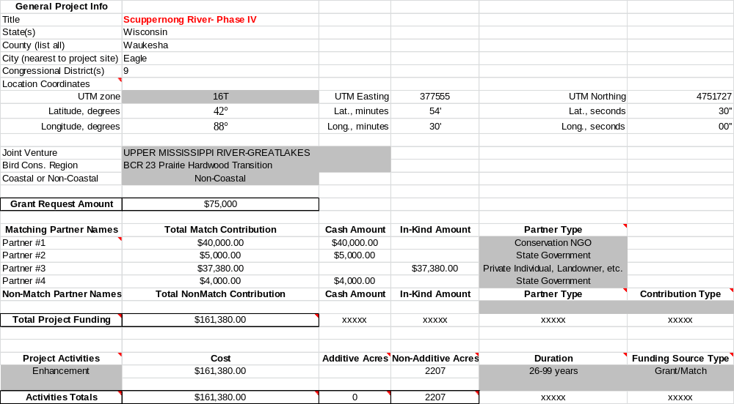
III. PROJECT DESCRIPTION, SCOPE OF WORK AND PARTNER INFORMATION:

- Project Description and Scope of Work:

The Scuppernong River Habitat Preservation Area (SRHPA) is a 3700-acre parcel within the Southern Unit of the Kettle Moraine State Forest (KMSF) that has been designated as such because it possesses excellent remnant plant communities that are critical refuges for many rare plants and animals. It is owned and managed by the Wisconsin Dept. of Natural Resources (WDNR) and within its boundaries are the Scuppernong Prairie and Kettle Moraine Low Prairie State Natural Areas, which together form the SRHPA core. Composed primarily of wet-mesic prairie, calcareous fen, and sedge meadow wetland plant communities, interspersed with upland oak savanna, this area supports a great diversity of native plants and animals. Past enhancement efforts of the remnant plant communities within the SRHPA have been accomplished with great success, a reflection of overall site quality and potential.
SRHPA is the largest wet-mesic prairie east of the Mississippi River, and is considered a “Wetland Gem” by the Wisconsin Wetland Association. The Southern Unit of the Kettle Moraine State Forest, within which the SRHPA lies, has been selected as a primary conservation area in the Wisconsin Land Legacy Report for its outstanding ecological qualities. According to the Wisconsin Wildlife Action Plan, this area harbors natural communities and species of global or continental significance, and is also one of the great opportunities for landscape-scale management of remnant low prairies in Wisconsin.
SRHPA has been selected as a Great Wisconsin Birding and Nature Trail in the Southern savanna region of Wisconsin by the Endangered Resource Program, has been identified as a statewide priority landscape for preservation and management in Managing Habitat for Grassland Birds – A Guide for Wisconsin, and designated an Important Bird Area (IBA). Species of management concern in the southeastern ridges and lowlands, of which this project is part, include Henslow’s sparrow, bobolink, sedge wren, grasshopper sparrow, blue-winged teal, Wilson’s phalarope, northern harrier, and short-eared owl. In addition this area could be critical to restoring a native prairie chicken flock and expanding the woodcock population.
The work proposed herein will focus on the invasive woody species, with some efforts put towards addressing the invasive Phragmites and cattail. In total, we intend to directly impact ~2218 acres of the ~3700 acre SPHRA.

NAWCA Project Goal:

NAWCA funds will be used to enhance wetland communities and some embedded upland sites within the SRHPA. The overall project goal is to enhance ~2218 acres of the 3,700 acre SHRA that is being threatened by dense stands of invasive herbaceous (e.g., Phragmites, narrowed leaved cattail) and woody species (e.g., buckthorn, box elder, honeysuckle, aspen, dogwood, willow). The proposed management areas have been identified as high priority sites as part of the SRHPA enhancement effort, and are meant to leverage previous efforts in this project area. The overall approach is to use NAWCA funds for new enhancement efforts (e.g., initial brush removal, aspen girdling, cattail/Phragmites control) and prescribed burning, and target matching funds for enhancement of areas previously addressed. The latter would include activities such as foliar spraying, re-mowing, and prescribed burning. With regards to proposed management areas delineated on the attached maps that appear to overlap with areas that have had previous work, this will either represent follow-up work (match funds) or different work (e.g., chainsaw work previously vs. fecon work currently).
Along with historic water level manipulation (i.e., ditching), woody species invading these communities is the key cause of degradation, and thus, will be our primary focus in this effort. We will initially address these in a number of ways, including direct removal, followed by prescribed burning. Follow-up work on these communities will likely include some combination of repeated mowing, foliar spraying, and continued prescribed burning, depending on the situation. More specifically, management of these areas will consist of: 1) large scale mowing of wetlands that have been invaded by woody invasive species, 2) forestry mowing (e.g., with fecon head) and tree sheering of the larger diameter trees in both wetland and upland sites, 3) cattail and Phragmites wicking with appropriate herbicides, 4) foliar spraying, cutting/treating, and basal barking of invasive woody species, 5) girdling of aspen encroaching high quality wetland areas, and 6) ~1622 acres of controlled burns.
In addition, direct control efforts will be initiated on invasive cattail (primarily narrow-leaved) and Phragmites, targeting smaller patches within large contiguous remnant habitats. This work will involve both foliar spraying and wicking, as appropriate.
With these intensive management activities, we will enhance the major remnant community types that comprise SRHPA, including oak savanna, wet-mesic prairie, sedge meadow, and calcareous fen, and by default, the populations of plants and animals that are part of these communities. Ultimately, there will be less land fragmented by invasive species (i.e., unsuitable habitat), which will benefit both common and rare plant and animal populations, including those requiring larger blocks of habitat.
Match funding for the SRHPA is diverse, and includes: 1) Pheasant Stamp, 2) Full Time Employee (FTE) staff time, 3) many hundreds of hours of volunteer time, and 4) a grant from the Kettle Moraine Natural History Association (KMNHA).

- Timetable:

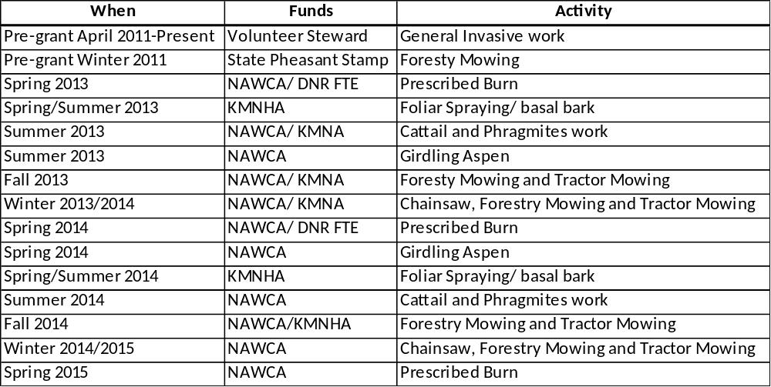

- Partner Information:

The Kettle Moraine Natural History Association is a nonprofit organization dedicated to helping preserve the outstanding features of biological interest in the Southern Unit of the Kettle Moraine State Forest. The KMNHA generates financial support through gift shop sales, donations, and membership dues.
Volunteer Steward Paul Mozina, a member of the KMNHA, has performed, on average, 500 hours of labor annually over the last three years, and will continue to volunteer his time with restoration efforts going on in the Scuppernong River Preservation Habitat Area throughout the grant period.
The WDNR Full Time Employees (FTE) will help with management activities in the SRHPA, as well as project oversight. In addition, Pheasant Stamp money has been used to remove heavy brush (i.e., “Fecon”, or forestry mowing) in the SRHPA.

IV. Project Financial Plan:

A. General Requirements:
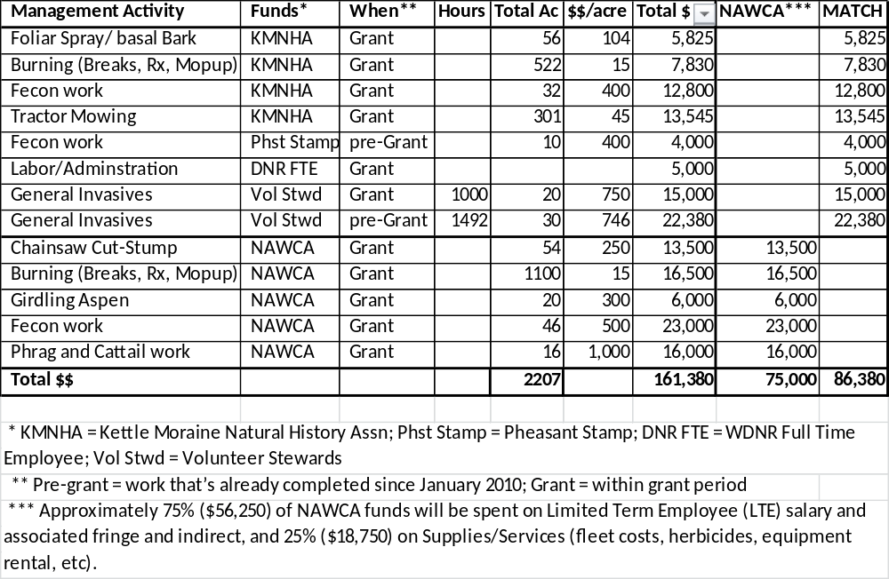
B. Financial Plan:
Category | NAWCA | KMNA | FTE | Pheasant Stamp | Volunteer Steward | Total
ENHANCEMENT: Salaries | $56,250 | $30,000 | $5,000 | $4,000.00 | $37,380 | $132,630
ENHANCEMENT: Supplies | $18,750 | $10,000 |  |  |  | $28,750
Totals: | $75,000 | $40,000 | $5,000 | $4,000 | $37,380 | $161,380
VI. Photographs of Project Area: Photographs: compliments of Ron Kurowski; retired naturalist at KMSF.

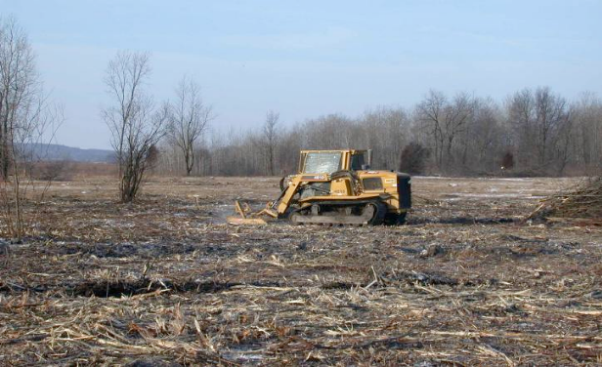
An example of a low soil disturbance All Surface Vehicle (ASV) with a forestry mower attached.
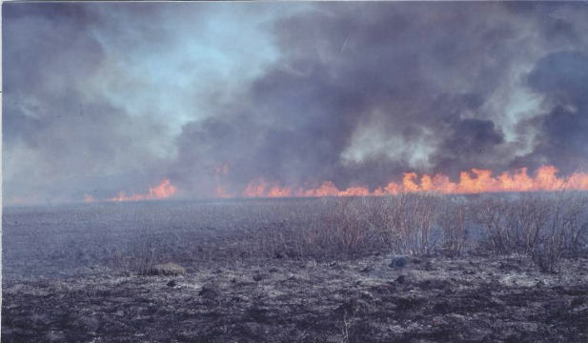
A controlled burn within the SHRA clears brushy material so native plants can establish themselves.
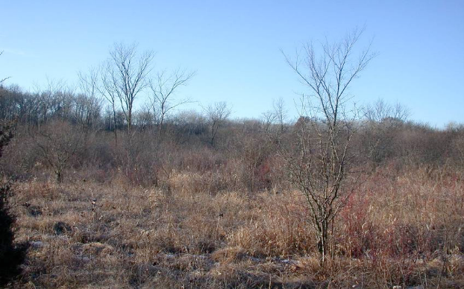
This is an area of SRHPA before restoration activities have been implemented.
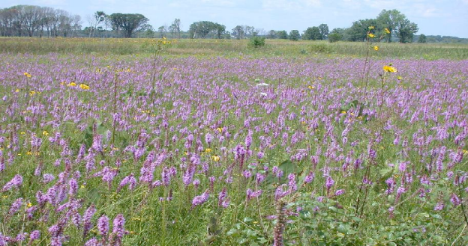
This is the expected outcome with restoration activities implemented. Species include Blazing Star, Prairie Dock, Compass Plant, and Yellow Coneflower

VII. Small Grants Evaluation Questions:
A. Partnerships:
As new partners become involved in this project, they naturally become aware of our goals and objectives, and subsequently increase the likelihood of expanding our partnerships in the future. And because most grants require match, the more partners the better. The partners currently involved with the Scuppernong River Wetland Restoration are the Wisconsin Dept. of Natural Resources (Bureau of Endangered Resources, Bureau of Parks, Division of Forestry, Bureau of Fisheries, and Pheasant Stamp), The Kettle Moraine Natural History Association, and Volunteer Stewards.

B. Waterfowl:
This project is within the Southeast Focus Area of Wisconsin in the Upper Mississippi River and Great Lakes Region Joint Venture. It is also in a township that is designated as critical habitat for projects under the joint venture. Waterfowl species will benefit from woody invasive species removal from degraded wetlands.

In addition, while outside the scope of this grant (but within the defined SHRPA goals), filling/plugging ditches, breaking tiles, and restoring the river to its natural stream bed will restore water levels that will provide wetland habitat for migrating and nesting waterfowl. Higher water levels coupled with the return of native grasses will increase habitat for waterfowl species. It is important to note that Phase IV will increase the continuity of native vegetation, thus creating large expanses of suitable prairie and wetland habitat.

Priority Population/Species:
The wetland restoration will provide resting, feeding, nesting and brood habitat for mallards. Mallards are a common nester and common migrant in this area. The area will also provide habitat for wood ducks that nest in nearby wooded areas. Wetland restorations will also provide resting and feeding habitat for American black ducks and northern pintails that use the Mississippi Flyway and migrate through this part of Wisconsin.

Other Species:
Giant Canada geese and blue-winged teal are also common nesters in this area. The area will also provide migration habitat for green-winged teal and northern shovelers.
C. Nongame and Other Migratory Birds:
The Southern Unit of the Kettle Moraine State Forest has been designated a statewide priority landscape for preservation and management in Managing Habitat for Grassland Birds – A Guide for Wisconsin, and declared an Important Bird Area (IBA). It is estimated that the KMSF holds ~100,000 adult birds of 137 species during the breeding season, and attracts 200 species of migrating land birds. A recent fall estimate concluded that ~2.35 million birds used this IBA as a stopover area. Besides the rare species listed below, many Special Concern species have been reported, including: Upland Sandpiper, Yellow-breasted Chat, King Rail, Black Tern, Black-billed cuckoo, Wood thrush, Veery, Worm-eating warbler, Blue-winged warbler, Least flycatcher, Eastern Meadowlark, Northern harrier, Upland sandpiper, Dickcissel, Barn owl, Bobolink, Brown thrasher, Grasshopper sparrow, Vesper sparrow, Field sparrow, Red-headed woodpecker, American woodcock, Yellow-billed cuckoo, Whip-poor-will, Yellow-breasted chat, Veery, Willow flycatcher, and short-eared owl. Additionally, priority Species of Greatest Conservation Need for this area include Blue-winged teal and American Bittern.

Shorebirds and grassland birds that require shallow marsh, sedge meadow and wet to wet-mesic prairie will benefit from restoration of these habitats. Species such as northern harrier and short-eared owl will also benefit since they require large tracts of habitat. Priority Species: The project is located in Bird Conservation Region 23. The project area provides or will provide nesting (*) or migrating habitat for American bittern, northern harrier, king rail*, greater yellowlegs, stilt sandpiper, white-rumped sandpiper, American woodcock*, Wilson’s phalarope*, black-billed cuckoo*, short-eared owl, willow flycatcher*, sedge wren*, marsh wren*, and Henslow’s sparrow*. Other Species: Species not on the Priority List, but noteworthy since they nest in the project area, include sora rail, sandhill crane, upland sandpiper, spotted sandpiper, common snipe, common yellowthroat, grasshopper sparrow, and bobolink.

D. Endangered Species:
The following is a list of rare (Threatened and Endangered) species within 1-mile of the project area. Note that there are many additional species of Special Concern.

Rare birds: Acadian Flycatcher, Bell's Vireo, Cerulean Warbler, Henslow's Sparrow, Hooded Warbler, Kentucky Warbler, Red-shouldered Hawk, Worm-eating Warbler, Yellow-throated warbler, and Red-necked Grebe. Rare herptiles: Northern Cricket Frog, Queensnake. Rare butterflies/moths: Silphium Borer Moth, Poweshiek Skipperling*, Swamp Metalmark. Rare leafhoppers: Red-tailed Prairie Leafhopper. Rare plants: Forked Aster, Kitten Tails, Prairie Indian-Plantain, Prairie Milkweed, Prairie Parsley, Purple Milkweed, Rough Rattlesnake-root, Yellow Gentian, Beaked Spike-rush, Prairie White-fringed Orchid*, Small White Lady's-slipper, and the Sticky False-asphodel.

* Note that the Poweshiek Skipperling is a Federal Candidate species, and the Prairie White-fringed orchid is Threatened at the Federal level.

E. Wetland Types:
This project will help to restore sedge meadows, wet-mesic prairies, and calcareous fens, all classified Palustrine Emergent Wetlands types.
F. Special Considerations:
The remnant plant communities that make up this tract of land benefit many common and rare neo-tropical migrant birds, waterfowl, plants, invertebrates, and other wildlife, as well as a great number of people. Given the KMSF’s proximity to three major metropolitan areas (Milwaukee, Madison, Chicago), this site presents an opportunity to not only enhance a significant wetland landscape, but educate a great number of people as well (note: no funds from this project will directly go to Education/Outreach). The KMSF has over 1 million visitors per year, and their field trips are attended by 3,000 people annually. With the work of many individuals, as well as past NAWCA and other state and federal grants, we have made great strides in enhancing the natural features of this site. This grant will go a long way towards maintaining those gains, as well as expanding our area of impact.
G. Climate Change:
Our remnant plant community enhancement efforts should increase the SRHPA’s ability to adapt to imminent changes in climate, and given that this is part of a larger complex that includes the North Unit of the Kettle Moraine State Forest, we hope to provide a corridor for latitudinal species movement if/when that need were to occur.

